From the Offices of:
Senator Bill Ferguson | Delegate Luke Clippinger | Delegate Brooke Lierman
Team 46 - Senator Bill Ferguson, Delegate Luke Clippinger, and Delegate Brooke Lierman -
Endorses Robbyn Lewis, Community Leader & Health Policy Specialist, to Replace Delegate Pete Hammen
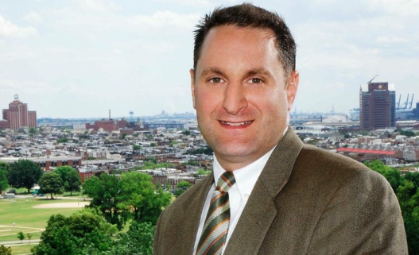BALTIMORE CITY, MD. (December 5, 2016) – Today, District 46 Delegate Pete Hammen announced that he will retire effective December 6, 2016, in order to serve as Chief of Operations in the Pugh Mayoral Administration.
The remaining members of the District 46 team, Senator Bill Ferguson and Delegates Luke Clippinger and Brooke Lierman, thank Pete Hammen for his dedication and commitment to the people of Baltimore City and for his enduring leadership as Chairman of the Health & Government Operations Committee.
For over 20 years, Delegate Hammen served the residents of the 46th District with incomparable constituent services. He has been a stalwart champion to expand affordable, high-quality health care for all, stimulate creative neighborhood development, and ensure all Baltimoreans have access to opportunity. Delegate Hammen’s creation of the Baltimore Regional Neighborhood Initiative (BRNI) will bring nearly $50 million in community development funds to the Baltimore region over the next four years. In addition, Delegate Hammen championed efforts to implement a new payment system for hospitals through use of a Medicaid waiver. Even in its infancy, this system has saved Marylanders and the state millions of dollars. Delegate Hammen will bring this first-class leadership experience with him to the Pugh Administration, and the District 46 team looks forward to working with him closely in his new capacity with the City of Baltimore.
“For the last six years of our service together, Pete has been an unbelievable mentor, leader, and friend,” said Sen. Bill Ferguson. “Mayor-elect Pugh could not have selected a more qualified and exceptional public servant to join her team in the Mayor’s Office. While I certainly will miss working with Pete in Annapolis, his transition to the Pugh Administration gives me great hope about the future of our City.”
To fill the vacancy created by Del. Hammen’s retirement, the District 46 team endorses Robbyn Lewis, a community activist who resides in the Patterson Park neighborhood and who works at the Maryland Health Benefit Exchange.
“Robbyn has been a leader in her neighborhood and in this City through her work spearheading greening initiatives, supporting public transit, and working in the field of public health. I am so grateful that I have had the chance to work with Pete for the past two years in the Assembly, I look forward to continuing to work with him in his new role, and I know that Robbyn will be an excellent addition to our state team,” said Del. Lierman.
Today, the Baltimore City Democratic Central Committee is posting notice of the process for replacement. Interviews for potential candidates will take place at the Southeast Anchor Library on December 21 at 5:00 p.m.
“Robbyn has been an active part of the 46th District for many years,” said Delegate Clippinger. “She knows how to bring people together to make our neighborhoods better places to live. She will use her skills as a leader and listener to find opportunities to create solutions to our City’s challenges. Furthermore, as the chair of the Democratic Caucus, I know she will provide valuable insights in the areas of public health and transportation.”
“As a resident who has been working to improve my community for many years, I have valued the relationship I have had with my state team, and I am excited by the opportunity to partner with them to continue promoting Baltimore’s needs in Annapolis, and working on the large variety of issues that confront the state legislature,” said Ms. Lewis. “I intend to formally submit my name to the Central Committee as a candidate tomorrow.”
Council President Jack Young said, “I look forward to continuing to work with Team 46 and supporting our collective efforts to build opportunity in Baltimore.” Robbyn Lewis will have the support of Councilman Eric Costello and Councilmembers-elect Shannon Sneed, Robert Stokes and Zeke Cohen.
“Robbyn’s reputation precedes her - she can now take the energy she has brought to improving her own community to the rest of the 46th district. I am excited to support her nomination, and look forward to working with her,” said Council-woman elect Shannon Sneed.
Robbyn Lewis is a public health professional, sustainability advocate, and community leader. She is on the boards of the Creative Alliance, the Southeast CDC, and Bikemore. She currently serves as the Special Assistant to the Executive Director of the Maryland Health Benefit Exchange. She served as a Peace Corps Volunteer in Niger, one of the least-developed countries in the world, where she helped to provide primary health education and services at a rural Maternal & Child clinic. She has a bachelor’s degree from the University of Chicago, and a masters of public health from Columbia University. She currently resides in the Patterson Park neighborhood.
-=-=-
State Senator Bill Ferguson · PO Box 25984, Baltimore, MD 21224, United States
This email was sent to Len@MarylandReporter.com. To stop receiving emails, click here.
You can also keep up with State Senator Bill Ferguson on Twitter or Facebook.
-=-=-

